Design Sketch

**Edmund’s Design Sketch:**

Colour Palette:

#FFD27C  #CBDAFA  #F1D4E2 

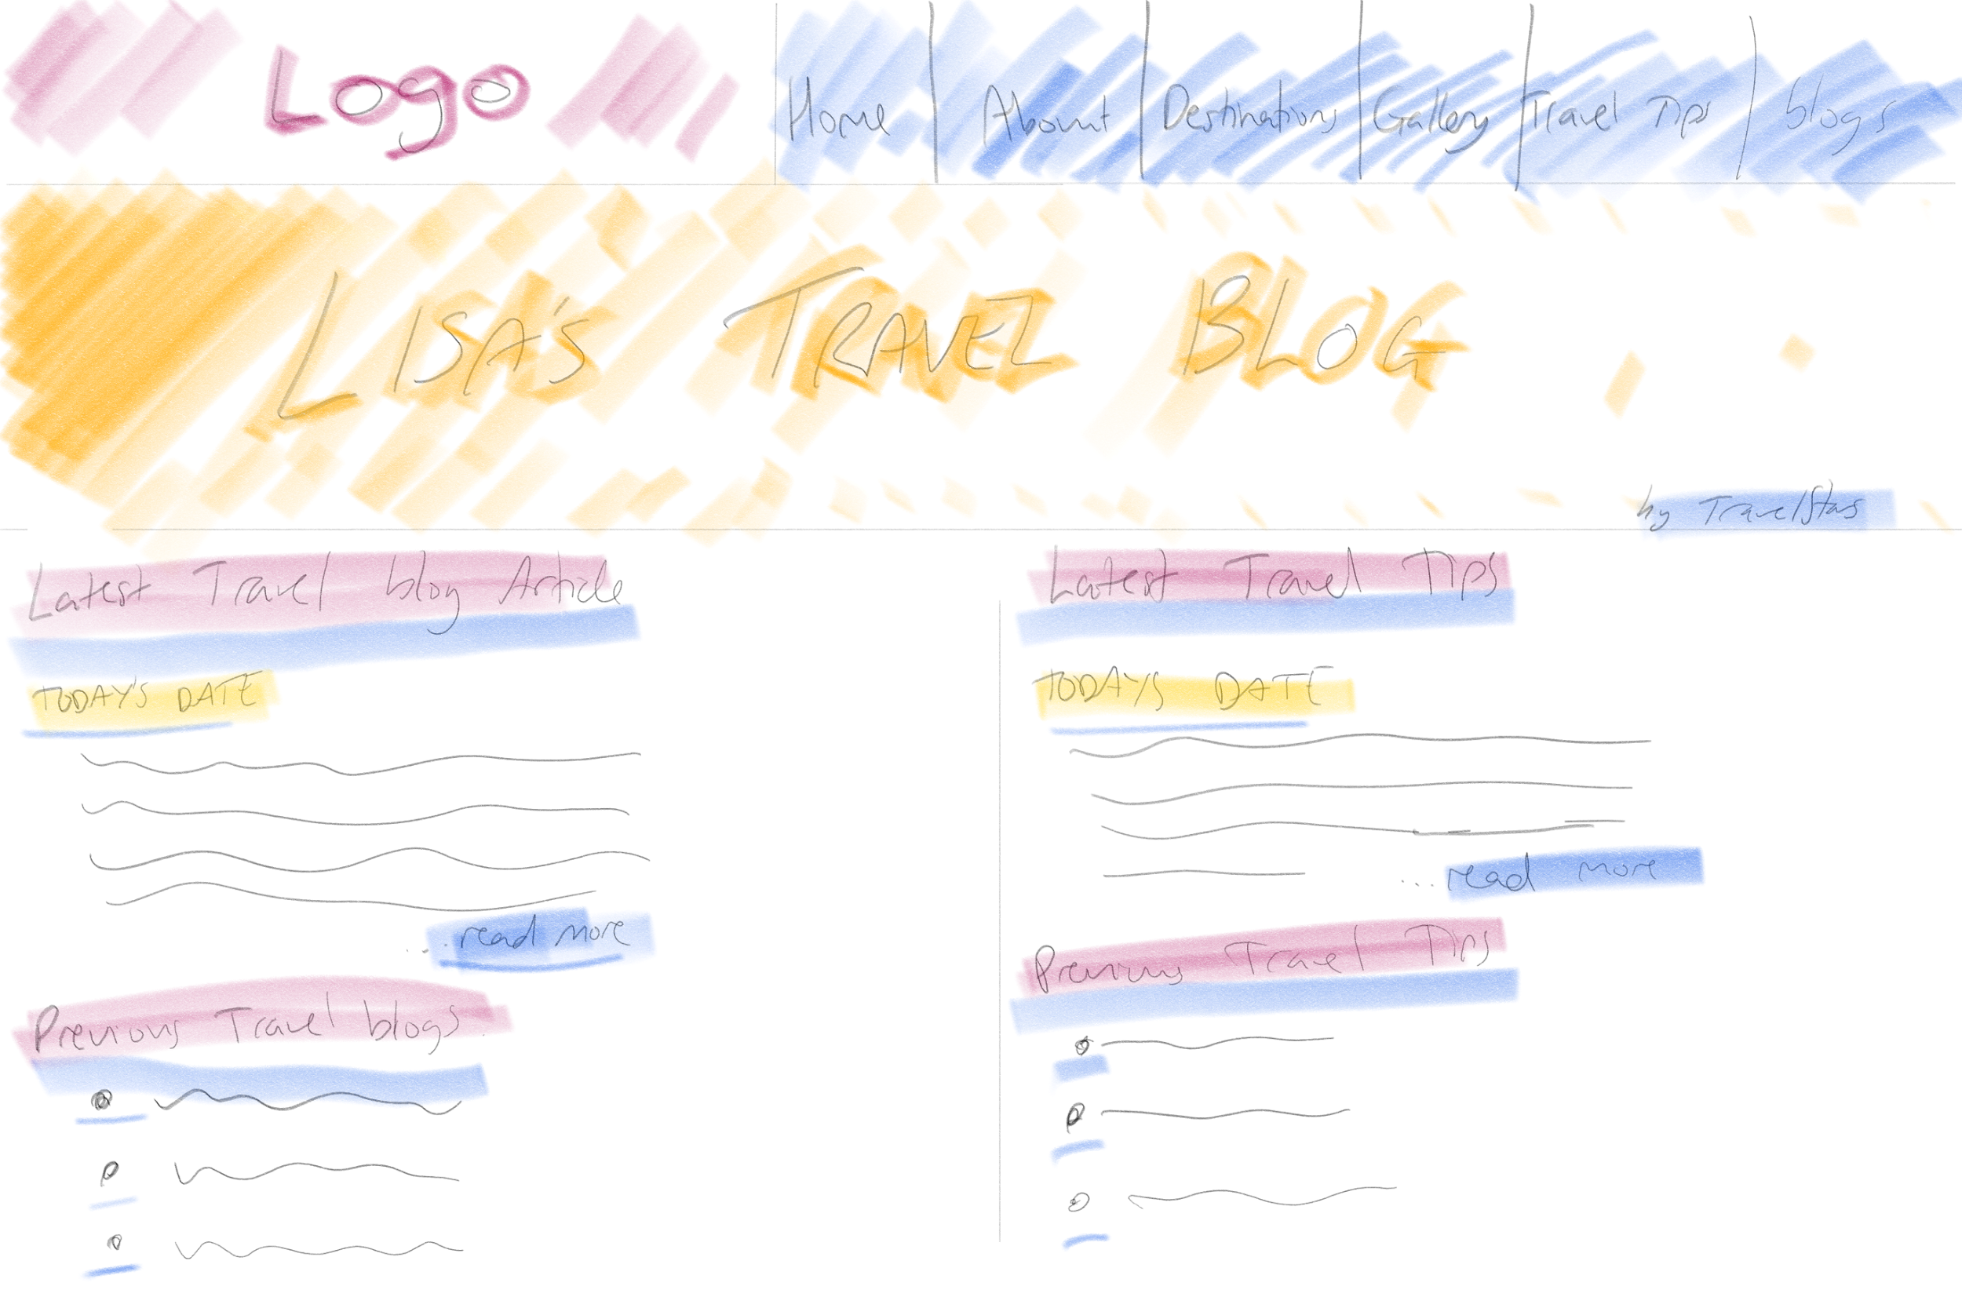

This is one of my sketches. It is also loosely based on our research of travel websites - <https://www.nomadicmatt.com/>.

I wanted to use some of the colours based on a sunset beach photo/s I saw on pinterest. I know list doesn’t want a large list of blogs on her main site, but I feel for the design read, some content here would be needed for a visitor. As such, my design read works something like the below:

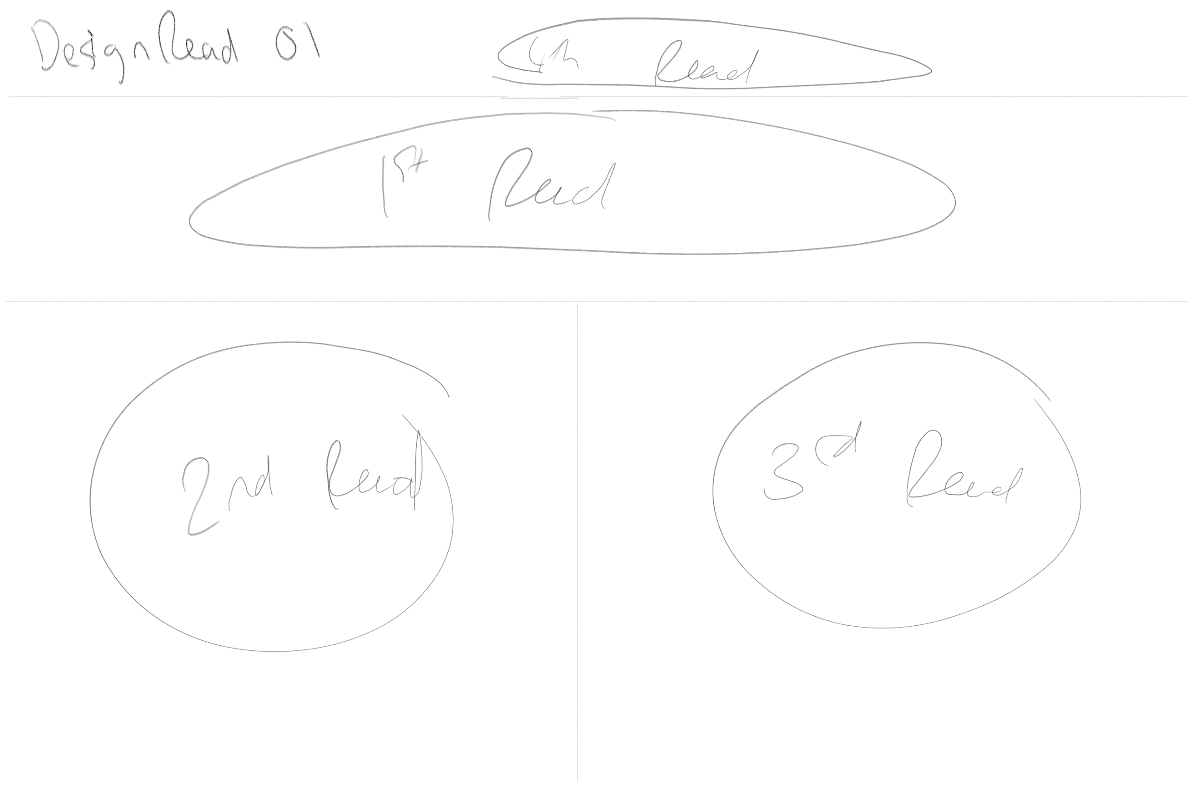

I feel that a visitor to the site will notice the logo immediately, as it is centered in the middle of the page and on learning what the content is going to be about, I hope to draw their attention to one of the blog posts on the left, and if it interests them, they can click into it to discover more, or read what’s on the right of the page, the travel tips to see if that is to their liking.

Hopefully with the right content, we should be able to keep them on the page, where they can look up and see the nav bar to scroll through the site.

My second sketch was as follows, using the same colour scheme:

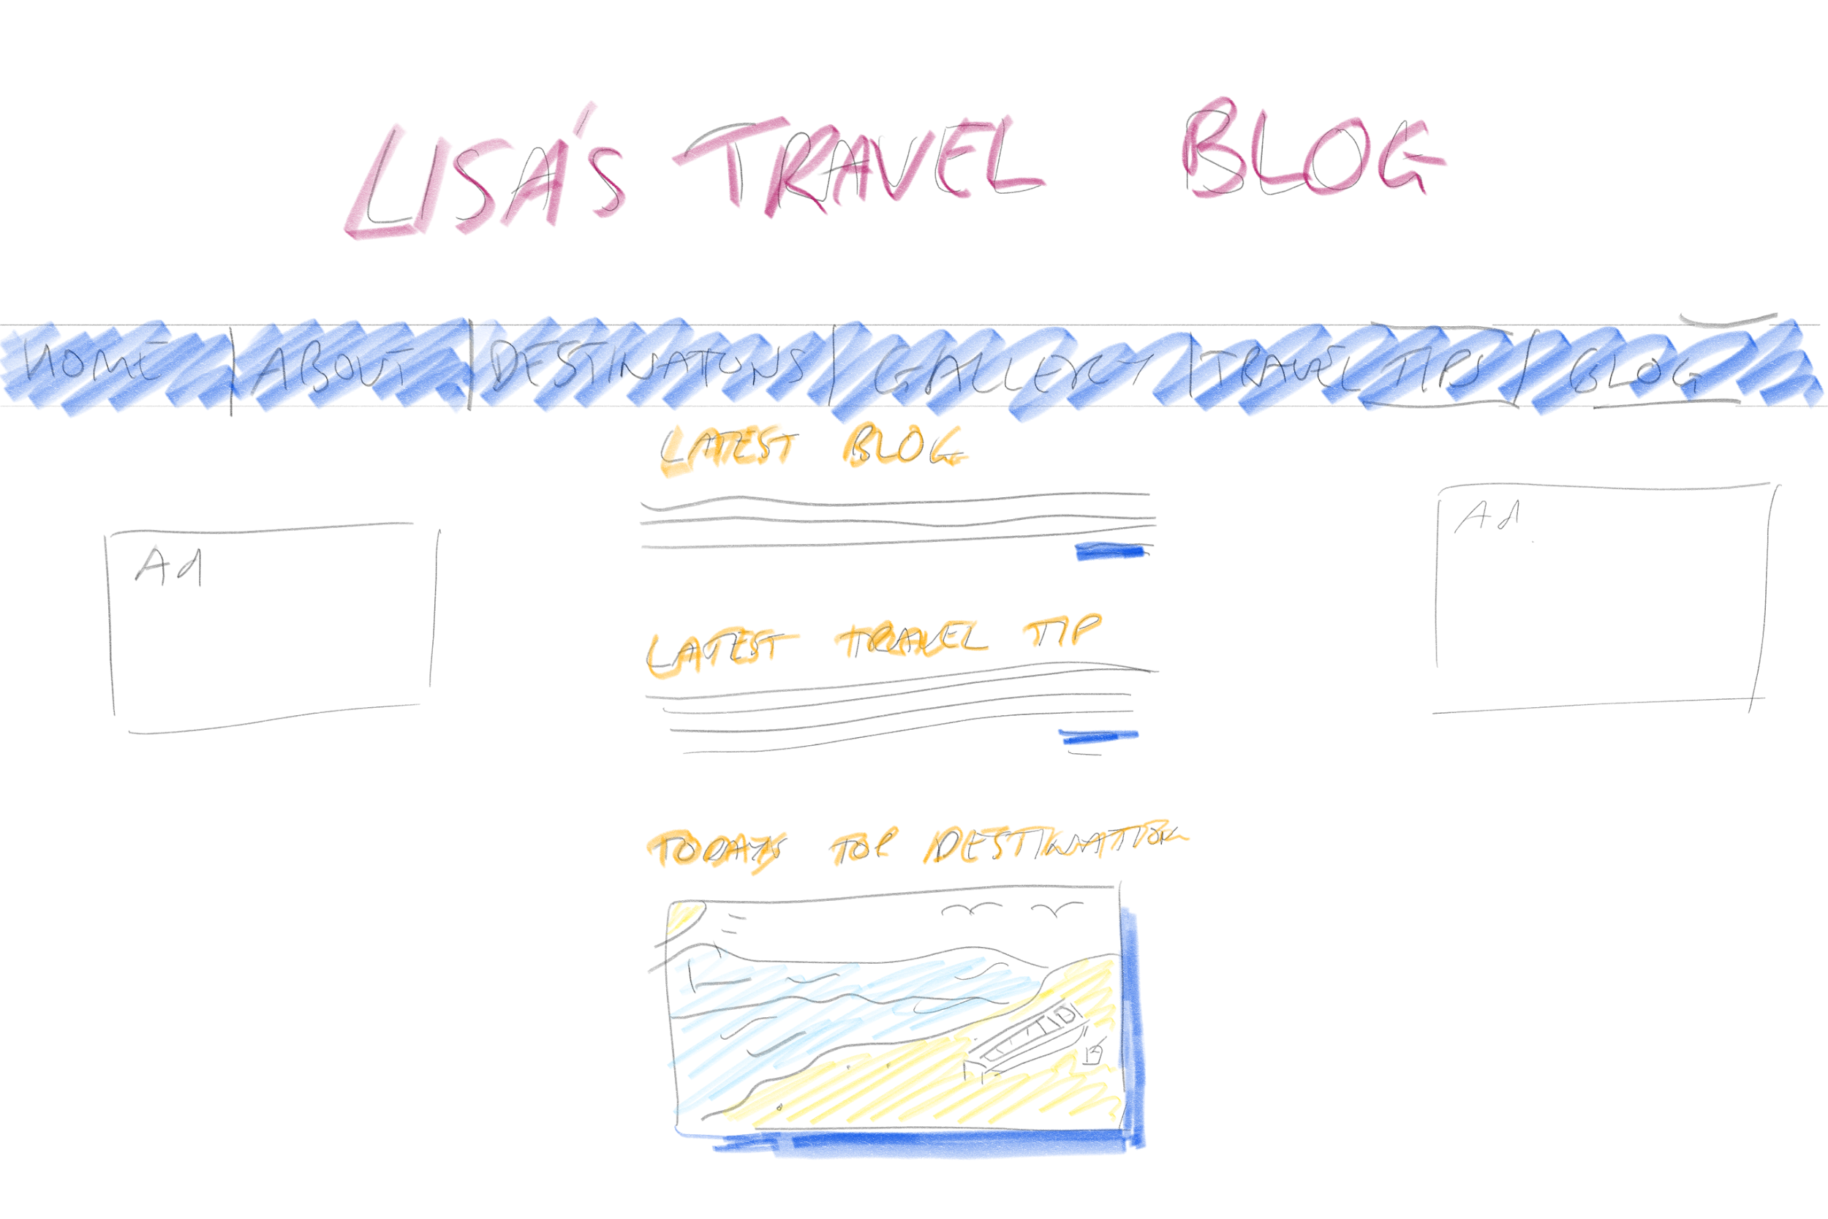

The colours were not as pronounced, and I wanted to create a bit of symmetry for this one. This could even work well as a mobile layout version.

I used less of the colours for the banner at the top and for the content, but used a darker colours for the nav bar to separate content from the banner.

I did take a little idea from <https://www.wanderingearl.com/>, but from the mobile site, and it did use a lot of whitespace, hopefully highlighting the content more.

With my design read, I feels the user will be drawn to the content first of all

I also purposely made the image stand out more, a way to try and make the content pop out to the user, by giving it a shadowy effect. As such, my design read is below:

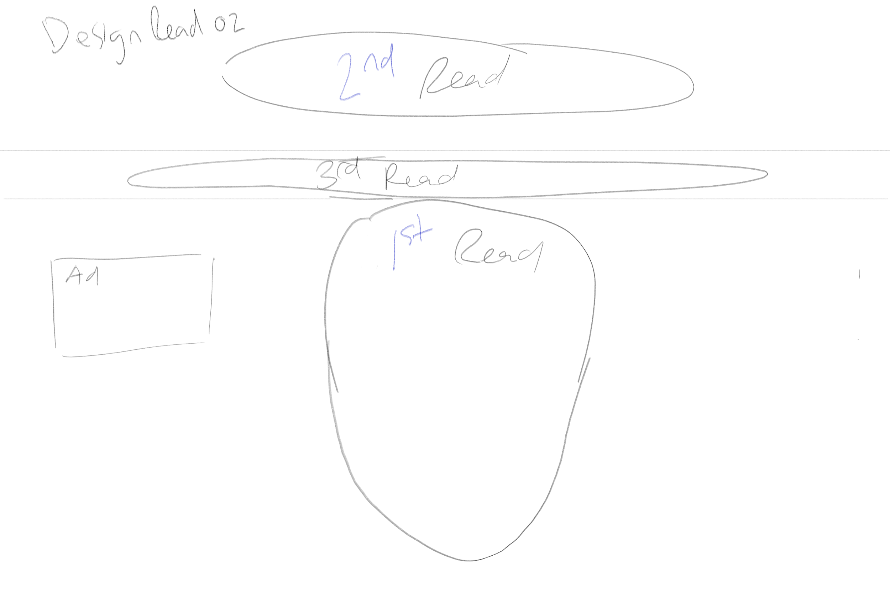

So by trying to add some shadow to the content, I try to give it a 3D effect and make it be the first thing the use notices. After getting the user to skim the contents, I hope to they will be curious as to the site, and review the banner, which will tell them it is a travel blog, before using the nav bar to search the site further or to keep scrolling down for more content.

Adam Kohler’s Design Sketches

Site sketches and color guide

About page sketch:

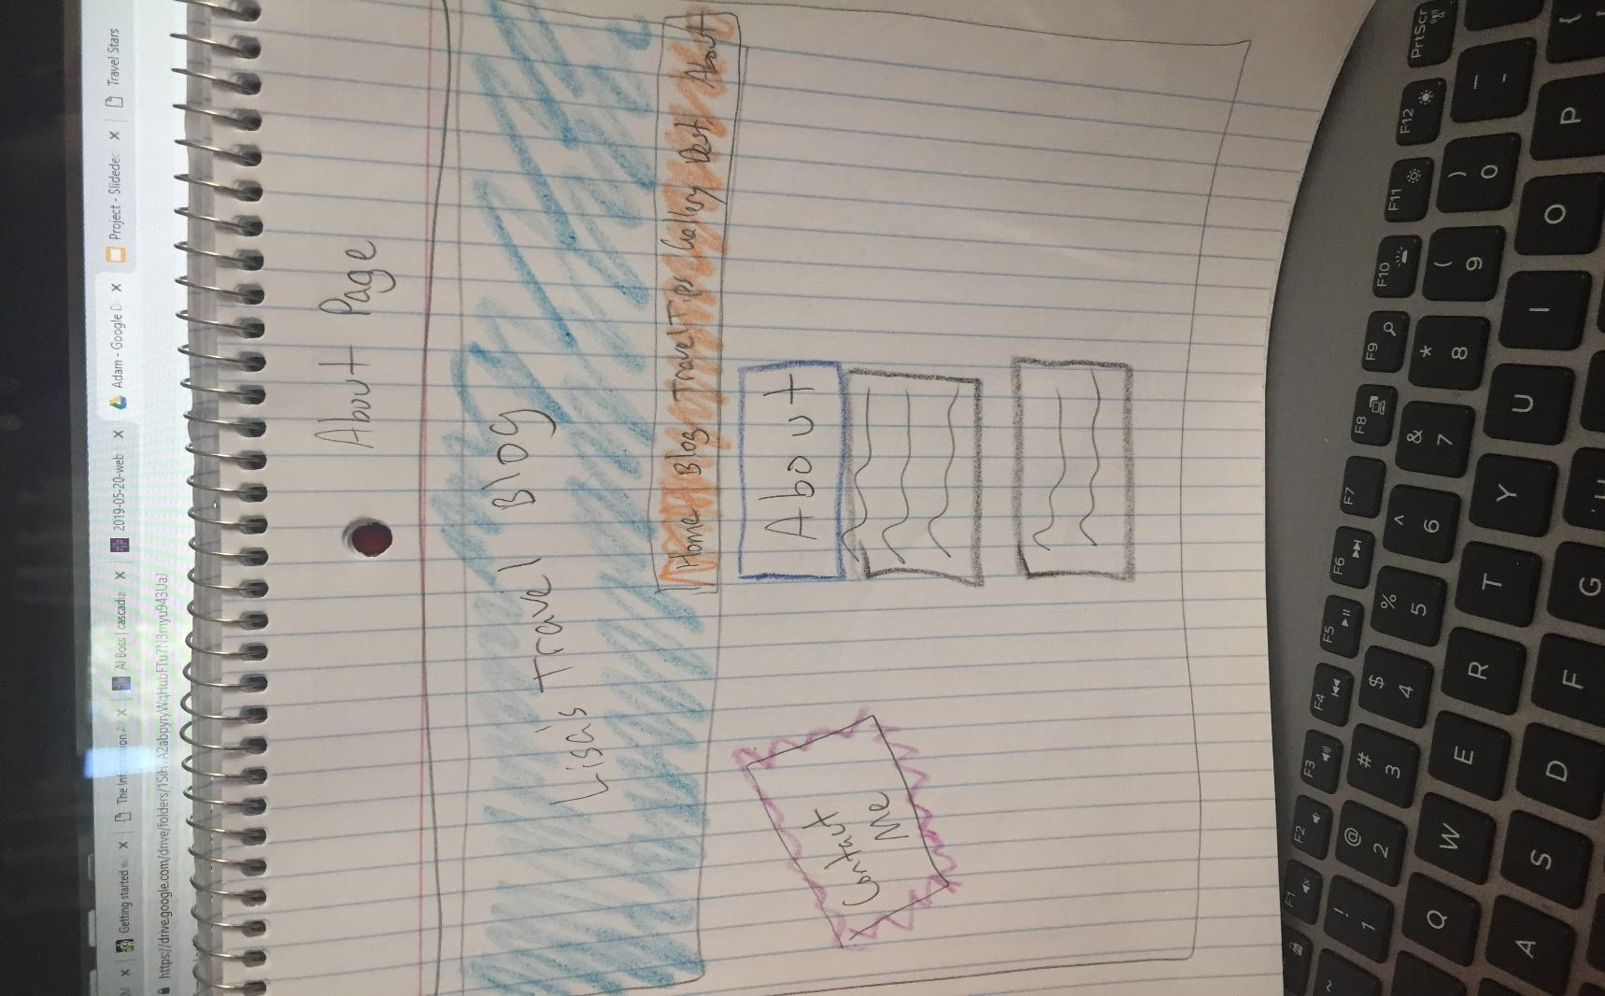

Gallery page sketch:

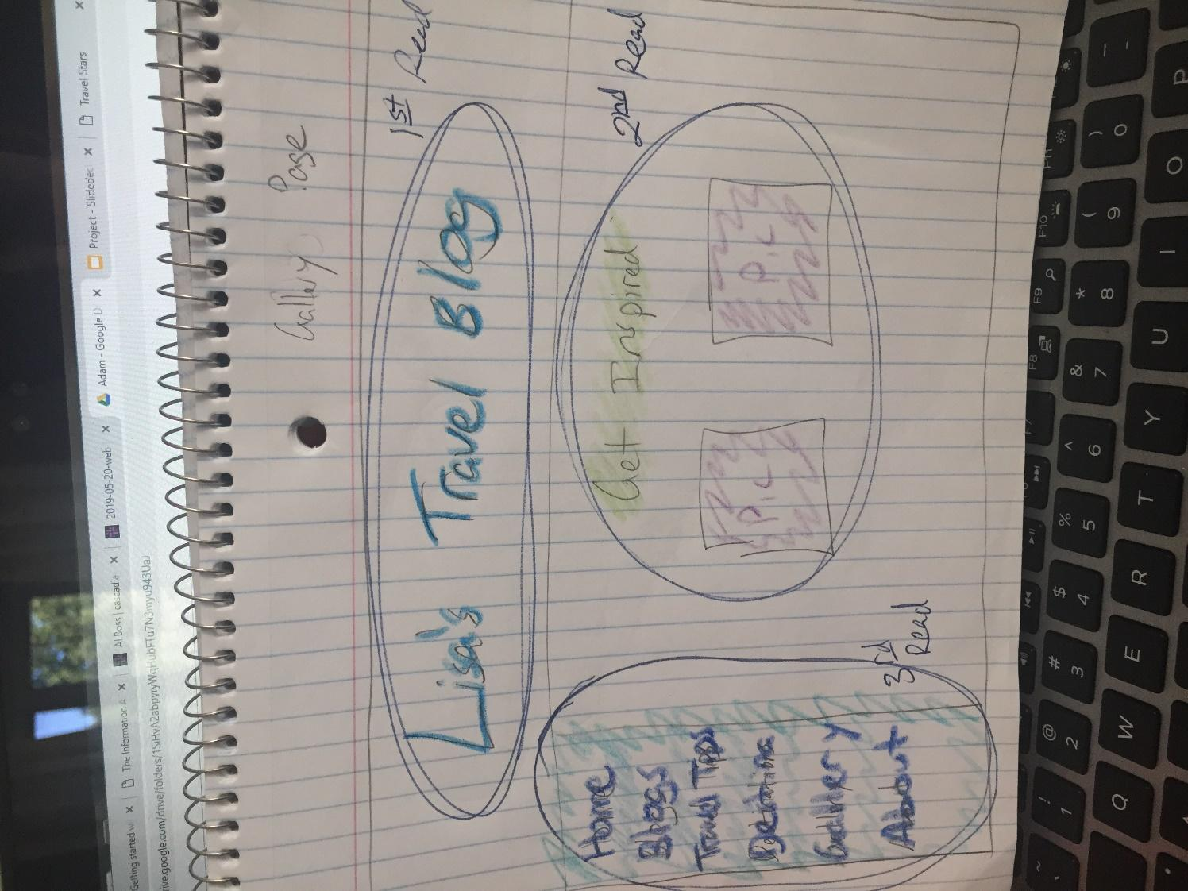

Color Palette ideas

|  |  |
| --- | --- |
|  | #1a1aff |
|  | #33ccff |
|  | #ff66ff |
|  | #66cc00 |
|  | #ff9900 |
|  |  |
|  |  |
|  |  |

Carson’s Design Sketches

Seth’s Design Sketches (left course)

